One Page Abstract Template

**Author 1**1**, Author 2**2**, Author 3**1

*1. Affiliation 1*

*2. Affiliation 2*

E-mail: your institutional email

This is a sample one-page abstract for submissions to VCSEL Day 2025, which will take place on September 19, 2025, in Łódź, Poland. Abstracts should be submitted in both Microsoft Word and PDF formats and must not exceed one page. Please do not alter the margins, header, or footer. Use only 10-point Arial for the main text. Figures may be provided in greyscale or color. Figure captions should be centered below the figures and set in 8-point font. References should appear at the end of the document, in the order they are cited in the main text, using 8-point font and left alignment. A suggested reference format is provided below.

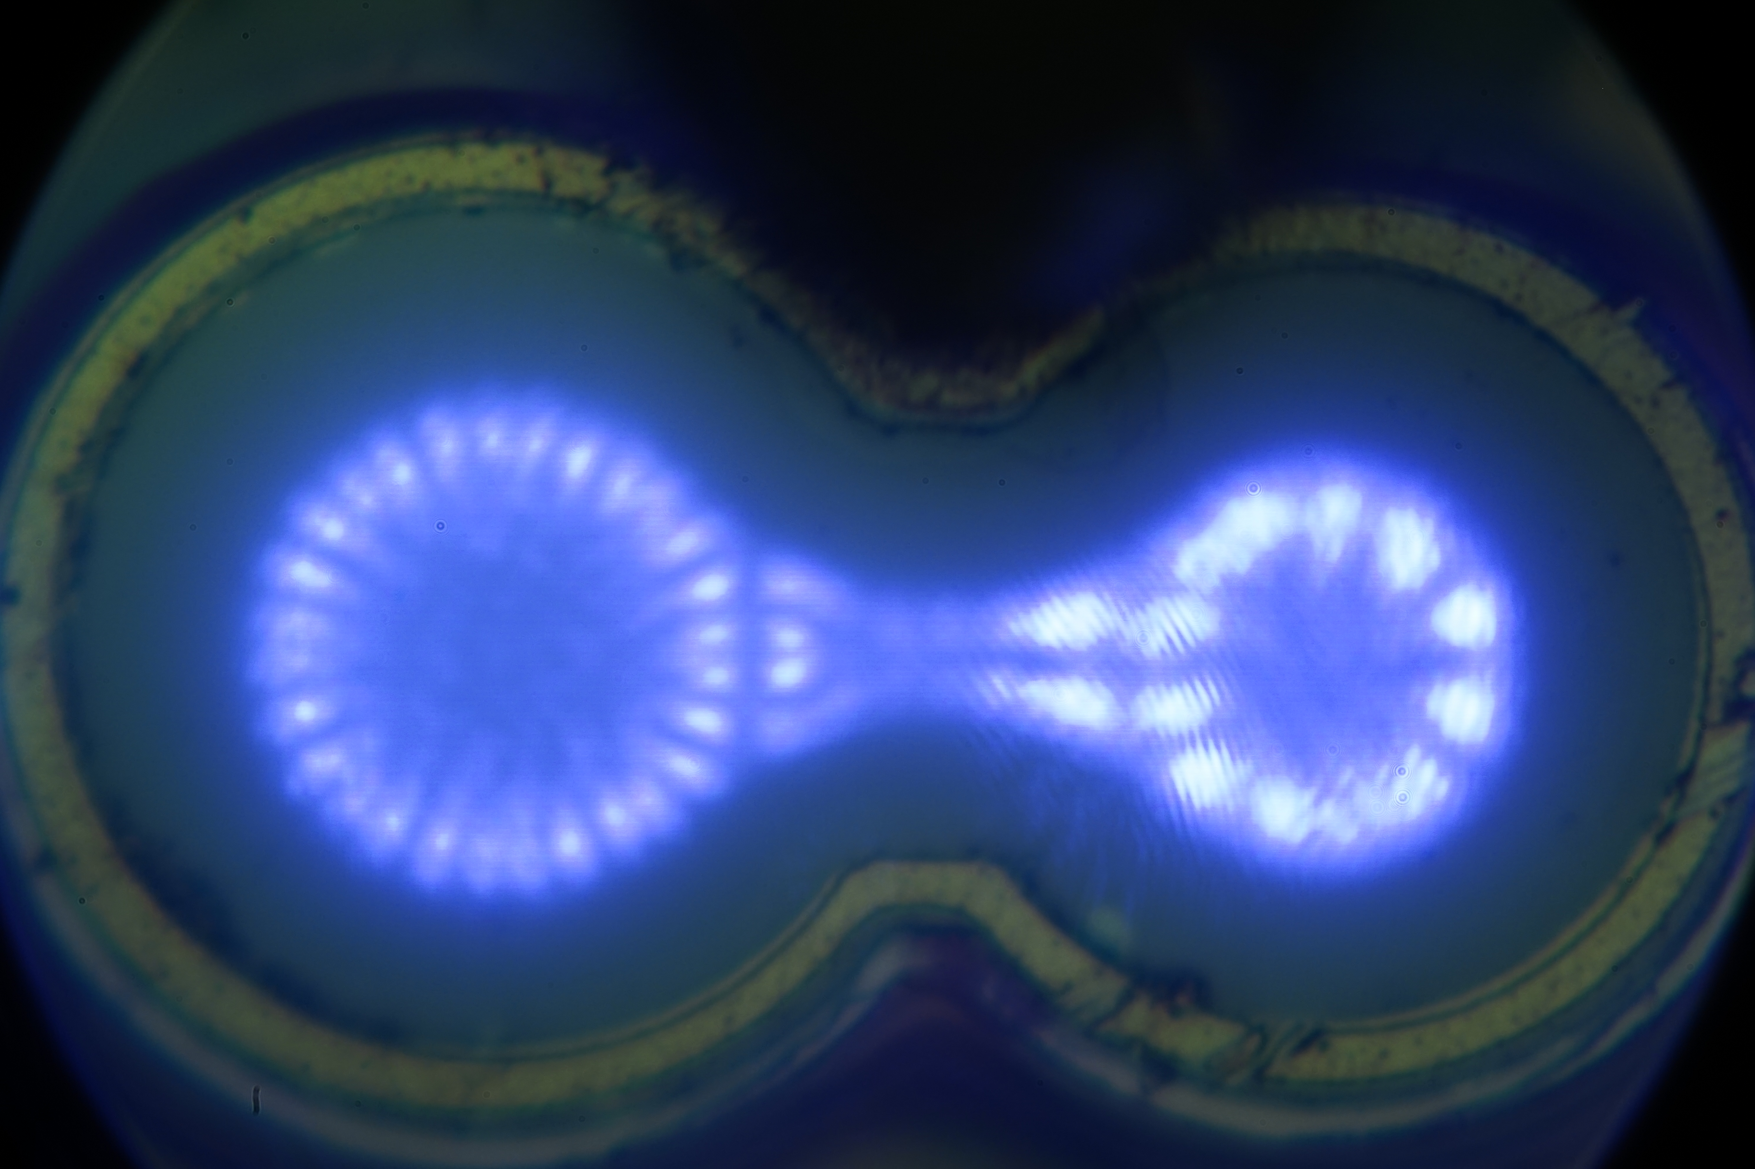

**Fig. 1** Near field of a double aperture 980 nm VCSEL

Please submit your abstract by August 29th via e-mail to **vcselday2025@info.p.lodz.pl**.

We look forward to seeing you all in Łódź.

**References**

[1] D.M. **Kuchta, Chap. 16 in *VCSELs*, R. Michalzik ed. (Springer, Berlin, 2013).**

**[2] H. Soda, K. Iga, C. Kitahara, and Y. Suematsu, "GaInAs/InP surface emitting injection lasers", Jpn. J. Appl. Phys. 18, 2329 (1979).**